**Exercise – 7.2**

Write a **MATLAB m-code** to find the time domain specifications for a 2nd order under-damped system, if given the closed loop transfer function parameters. Plot the step response for the same and find the final value of response.

**Initial Calculations**:

Closed loop transfer function of a 2nd order system is of the form:

$$\frac{G(s)}{1+G\left(s\right)H(s)}=\frac{{ω_{n}}^{2}}{s^{2}+2δω_{n}s+{ω_{n}}^{2}}$$

Comparing the above with

$$\frac{G\left(s\right)}{1+G\left(s\right)H\left(s\right)}=\frac{c}{as^{2}+bs+c}=\frac{c/a}{s^{2}+{(b}/{a)}s+\left(c/a\right)}$$

1. Accept from the user, values of ***a***, ***b*** and ***c.***
2. Calculate the un-damped natural frequency, *ωn*
3. Calculate the damping ratio, δ
$$δ=\frac{b}{2aω_{n}}$$

4. Verify if it is an under-damped system (0<δ<1) and proceed
5. Calculate damped frequency, *ωd*
6. Calculate θ
$$θ=\cos^{-1}δ$$

7. Delay time, *td*
8. Rise time, *tr*
9. Peak time, *tp*
10. Peak overshoot, *Mp*
11. Settling time, *ts*

*For a 2% steady state error*

$$t_{s}=\frac{4}{δω_{n}}$$

*For a 5% steady state error*

$$t_{s}=\frac{3}{δω_{n}}$$

**M-code**:

% Ex-7.2 (Control Systems)

% Sambhav R Jain

% 107108103

clc;

clear all;

close all;

fprintf('Program to calculate the time-domain specifications of a 2nd order under-damped system\n\n')

while 1

a = input('Enter the coefficient of s^2 in the closed loop transfer function: ');

b = input('Enter the coefficient of s^1 in the closed loop transfer function: ');

c = input('Enter the coefficient of s^0 in the closed loop transfer function: ');

wn = sqrt(c/a);

del = b/(2*a*wn);

if del<1 && del>0

break

end

del

fprintf('This is not an under-damped system. Please re-enter.\n\n')

end

wd = wn*sqrt(1-del^2);

theta = acos(del);

disp('Damping ratio: ');

del

disp('Un-damped natural frequency wn (rad/s): ');

wn

disp('Damped frequency wd (rad/s): ');

wd

disp('Delay time (s): ');

td = (1+0.7*del)/wn

disp('Rise time (s): ');

tr = (pi-theta)/wd

disp('Peak time (s): ');

tp = pi/wd

disp('Peak overshoot (%): ');

Mp = exp(-del*pi/(sqrt(1-del^2)))*100

disp('Settling time for a 2% steady state error (s): ');

ts = 4/(del*wn)

disp('Settling time for a 5% steady state error (s): ');

ts = 3/(del*wn)

t = 0:0.01:ts+1;

out = 1-exp(-del*wn.*t).*sin(wd.*t+theta)/sqrt(1-del^2);

plot(t,out);

grid on;

xlabel('Time(s) ---->');

ylabel('Response ---->');

title('Step response of a 2nd order under-damped system');

**Terminal Display:**

Program to calculate the time-domain specifications of a 2nd order under-damped system

Enter the coefficient of s^2 in the closed loop transfer function: 1

Enter the coefficient of s^1 in the closed loop transfer function: 60

Enter the coefficient of s^0 in the closed loop transfer function: 500

del =

1.3416

This is not an under-damped system. Please re-enter.

Enter the coefficient of s^2 in the closed loop transfer function: 1

Enter the coefficient of s^1 in the closed loop transfer function: 30

Enter the coefficient of s^0 in the closed loop transfer function: 500

Damping ratio:

del =

0.6708

Un-damped natural frequency wn (rad/s):

wn =

22.3607

Damped frequency wd (rad/s):

wd =

16.5831

Delay time (s):

td =

0.0657

Rise time (s):

tr =

0.1391

Peak time (s):

tp =

0.1894

Peak overshoot (%):

Mp =

5.8328

Settling time for a 2% steady state error (s):

ts =

0.2667

Settling time for a 5% steady state error (s):

ts =

0.2000

**Waveform:**

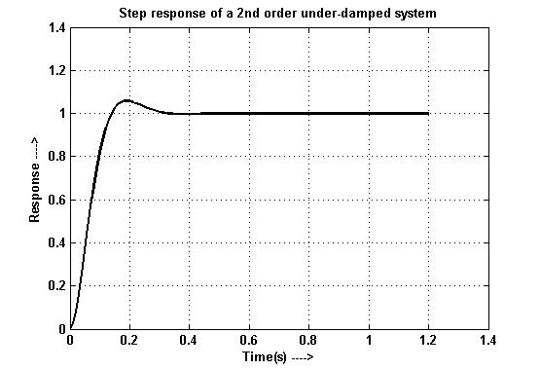

**Results:**

Hence MATLAB is used to determine the time domain specifications of a 2nd order under-damped system imposed with a step input. The response is plotted.